***[UI UX design](https://www.edureka.co/ui-ux-design-certification-course)***

In today’s digital age, [***UI UX design***](https://www.edureka.co/ui-ux-design-certification-course) plays an important role in creating successful products. UI/UX design is a combination of two design disciplines that work together to create a great user experience. In this blog on UI UX design tutorial, we will discuss all about **UI UX Design Tutorial**, with the following topics.

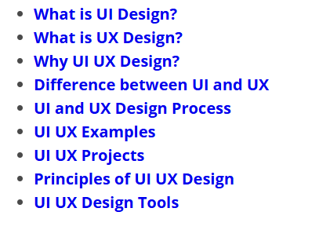

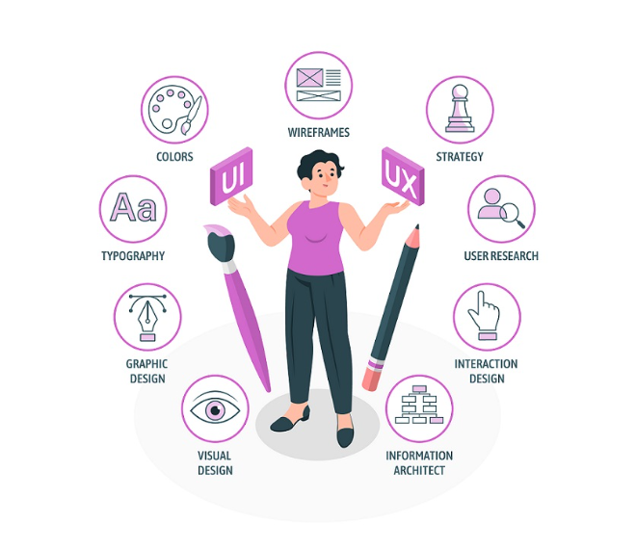

**What is UI Design?**

User Interface (UI) design is the process of designing the interface of a digital product. The goal of UI design is to create a visually appealing and user-friendly interface that allows users to interact with the product easily. UI designers work on designing the layout, color scheme, typography, and visual elements of the product.

UI design also involves creating wireframes and prototypes of the product to help visualize the final product. Wireframes are basic sketches of the layout of the product, while prototypes are working models that allow designers to test the product and get feedback from users.

**What is UX Design?**

User Experience (UX) design is the process of creating a product that meets the needs of the user. The goal of UX design is to create a product that is easy to use and provides a seamless experience for the user. UX designers work on understanding the needs of the user and creating a product that meets those needs.  
UX design involves researching the user, creating user personas, and designing user journeys. User personas are fictional characters that represent the user and their needs. User journeys are the steps that the user takes to complete a task using the product.

**Why UI UX Design?**

UI UX design is important because it helps to create products and services that are easy to use, intuitive, and enjoyable for users. A well-designed user interface (UI) and user experience (UX) can help to increase user engagement, retention, and satisfaction, which can ultimately lead to higher conversions and revenue for businesses.

Here are some reasons why UI UX design is important:

* **User satisfaction:** UI UX design helps to create products that meet the needs and expectations of users. By understanding user behaviors, emotions, and pain points, designers can create a seamless and enjoyable experience that satisfies users and keeps them coming back.
* **Brand loyalty:** A well-designed UI and UX can help to build brand loyalty and increase customer retention. By providing users with a positive experience, they are more likely to become loyal customers and advocates for the brand.
* **Increased engagement:** A user-friendly interface and a satisfying experience can help to increase user engagement with a product. Users are more likely to spend more time on a product that is easy to use and enjoyable, leading to increased user engagement and a higher likelihood of conversion.
* **Competitive advantage:** In a crowded marketplace, a well-designed UI and UX can give a product a competitive advantage. By offering a superior user experience, a product can stand out from its competitors and attract more users.
* **Increased revenue:** A positive user experience can lead to increased revenue for businesses. By creating a product that is easy to use, intuitive, and enjoyable, businesses can increase conversions and ultimately generate more revenue.

**Difference between UI and UX**

**UI (User Interface) and UX (User Experience)** are two essential components of product design that are often used interchangeably, but they refer to different aspects of the design and development process.

UI design focuses on creating visually attractive and intuitive interfaces that users can easily navigate and interact with. It includes the graphical and interactive elements of a product such as buttons, menus, icons, colors, typography, and other graphical components. UI designers aim to make the product look beautiful and appealing, and the interface should be easy to use, intuitive, and visually pleasing.

On the other hand, UX design involves creating a satisfying and seamless experience for users when they interact with a product. UX design takes into account the entire user experience, from the moment they start interacting with the product until they complete their task. UX designers conduct research, analyze user behaviours and emotions, create user personas, and develop prototypes to ensure that the product meets the users’ needs in a satisfying way.

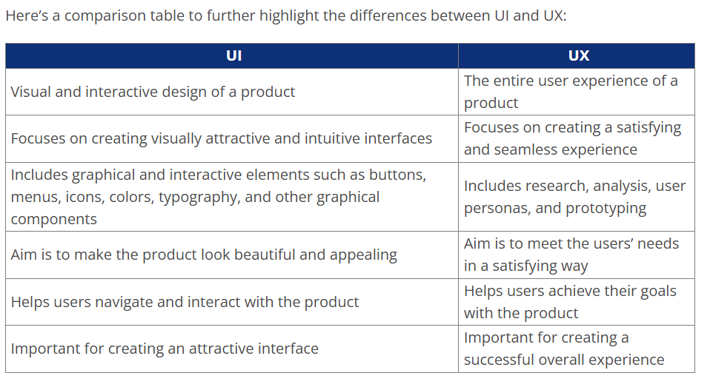

In summary, while UI design and UX design are related, they are two distinct concepts that serve different purposes in product design. A well-designed UI is essential for creating an attractive and intuitive interface, but a successful UX requires research, analysis, and prototyping to ensure that the product meets users’ needs and provides a satisfying and seamless experience.

**UI and UX Design Process**

The UI and UX design process involves several steps. Here are the steps involved in the process:

* Research and Analysis

The first step in the design process is to research and analyze the product and the user. This involves understanding the user’s needs, preferences, and behaviors. UX designers use various research methods such as surveys, interviews, and user testing to gather data.

* User Persona Creation

After gathering data, UX designers create user personas. User personas are fictional characters that represent the user and their needs. User personas help designers understand the user’s needs and design a product that meets those needs.

* User Journey Mapping

The next step is to design user journeys. User journeys are the steps that the user takes to complete a task using the product. UX designers create user journeys to identify pain points and areas of improvement in the product.

* Wireframe Creation

After designing user journeys, UI designers create wireframes. Wireframes are basic sketches of the layout of the product. Wireframes help designers visualize the final product and make changes before moving to the prototyping stage.

* Prototyping

After creating wireframes, UI designers create prototypes. Prototypes are working models that allow designers to test the product and get feedback from users. Prototyping helps designers identify areas of improvement and make changes before launching the product.

* User Testing

The final step is user testing. UX designers conduct user testing to get feedback from users and identify areas of improvement. User testing helps designers improve the product and create a seamless user experience.

**UI UX Examples**

Here are some examples of UI UX design in action:

* **Apple’s iPhone:** Apple’s iPhone is a great example of UI UX design. The user interface is intuitive and easy to navigate, with simple and attractive design elements that make it a pleasure to use. The user experience is also carefully crafted to be seamless and enjoyable, with features such as Face ID and intuitive gestures that make using the iPhone a pleasure.
* **Airbnb:** Airbnb’s user interface is clean and simple, with easy-to-use search filters that help users find the perfect accommodation. The user experience is also carefully crafted, with personalized recommendations and reviews that help users make informed decisions about where to stay.
* **Google Maps:** Google Maps is an example of excellent UI UX design. The user interface is clean and easy to use, with intuitive features such as voice navigation and real-time traffic updates that make it a pleasure to use. The user experience is also carefully designed, with features such as personalized recommendations and reviews that help users find the best places to go.
* **Slack:** Slack is an example of UI UX design that helps to improve productivity. The user interface is simple and intuitive, with easy-to-use messaging and collaboration tools that help teams stay connected and get work done. The user experience is also carefully crafted, with features such as integrations and custom notifications that help users stay on top of their work.
* **Spotify:** Spotify’s user interface is carefully designed to be easy to use and visually attractive. The user experience is also carefully crafted, with personalized recommendations and playlists that help users discover new music and keep them engaged with the platform.

These are just a few examples of UI UX design in action. In each case, the user interface and user experience are carefully crafted to be intuitive, enjoyable, and engaging, which helps to improve user satisfaction and drive business success.

**UI UX Projects**

Here are a few examples of UI UX projects:

* **E-commerce Website:** E-commerce websites require careful consideration of both UI and UX design principles. The UI should be visually appealing, with a clear and easy-to-use layout. The UX should be designed to make the shopping experience as easy and convenient as possible. For example, features such as one-click ordering and personalized product recommendations can improve the user experience.
* **Mobile App:** Mobile app UI UX design is becoming increasingly important as more people use smartphones and tablets. The UI should be designed to work well on small screens, with easy-to-use navigation and clear calls to action. The UX should be designed to be intuitive and seamless, with features such as push notifications and in-app messaging to keep users engaged.
* **Healthcare Platform:** Healthcare platforms require a careful balance of UI and UX design. The UI should be designed to be clean and simple, with easy-to-use navigation and clear calls to action. The UX should be designed to provide users with the information they need to make informed healthcare decisions, such as patient history and treatment options.
* **Financial Dashboard:** Financial dashboards require careful consideration of both UI and UX design principles. The UI should be designed to be clean and easy-to-use, with clear calls to action and visual cues to help users understand their financial situation. The UX should be designed to provide users with easy access to their financial information, such as account balances and transaction history.
* **Gaming App:** Gaming app UI UX design is becoming increasingly important as more people play mobile games. The UI should be designed to be visually appealing, with clear calls to action and easy-to-use navigation. The UX should be designed to keep users engaged, with features such as social sharing and in-game rewards.

These are just a few examples of UI UX projects. In each case, the goal is to create a product that meets the needs of the user and provides a positive user experience. The design process is iterative, and designers often make changes and improvements based on user feedback to ensure that the final product is user-friendly and enjoyable.

**Principles of UI UX Design**

Here are some of the key principles of UI and UX design:

**User-Centered Design:** The most important principle of UI UX design is to focus on the needs and preferences of the user. Designers should conduct research to understand the user’s behavior, goals, and pain points and design the product to meet their needs.  
**Consistency:** Consistency in UI UX design is important for creating a predictable and easy-to-use interface. Elements such as typography, color, and layout should be consistent throughout the product.  
**Clarity:** The UI should be clear and easy to understand, with a clear hierarchy of information and a logical flow. Users should be able to easily find the information they need and complete tasks without confusion.  
**Simplicity:** Simple UI UX design can make a product easier to use and more visually appealing. Designers should aim to eliminate unnecessary elements and create a clean and minimal design.  
**Accessibility:** Accessibility is an important consideration in UI UX design. Designers should ensure that the product is usable by people with disabilities, such as those who are visually impaired or have motor disabilities.  
**Feedback:** Providing feedback to the user is an important principle of UI UX design. Users should receive feedback when they complete an action, such as a confirmation message or visual cue.  
**Flexibility:** UI UX design should be flexible enough to accommodate a range of user preferences and needs. For example, users should be able to customize the interface to suit their preferences, such as changing the font size or color scheme.  
**Performance:** UI UX design should take into account the performance of the product. Users should not experience delays or slow loading times, which can negatively impact the user experience.  
By following these principles, designers can create products that are intuitive, easy to use, and enjoyable for users.

**UI UX Design Tools**

There are a wide range of tools available for UI/UX design, each with their own strengths and weaknesses. Here are some of the most popular tools used by UI/UX designers:

**Sketch:** Sketch is a popular vector graphics editor that is widely used by UI/UX designers. It is particularly useful for creating wireframes, prototypes, and user interfaces.  
**Adobe XD:** Adobe XD is a vector-based tool that is designed specifically for UI/UX design. It allows designers to create high-fidelity prototypes and user interfaces, as well as collaborate with team members and clients.  
**Figma:** Figma is a cloud-based design tool that is popular for its collaborative features. It allows multiple users to work on a project simultaneously, making it ideal for remote teams.  
**InVision:** InVision is a prototyping and collaboration tool that is popular among UI/UX designers. It allows designers to create interactive prototypes, conduct user testing, and collaborate with team members and stakeholders.  
**Axure RP:** Axure RP is a wireframing and prototyping tool that is popular among UX designers. It allows designers to create complex interactive prototypes and user flows, as well as conduct user testing and gather feedback.  
**Marvel:** Marvel is a prototyping tool that allows designers to create high-fidelity prototypes and user interfaces. It is particularly useful for creating interactive animations and transitions.  
**Balsamiq:** Balsamiq is a wireframing tool that is popular for its simplicity and ease of use. It allows designers to create quick and simple wireframes, making it ideal for rapid prototyping.  
These are just a few of the many tools available for UI/UX designers. Ultimately, the choice of tool will depend on the designer’s individual needs and preferences, as well as the requirements of the project.

**Conclusion**

UI and UX design are important aspects of creating any digital product. UI designers work on designing the interface of the product, while UX designers work on creating a product that meets the needs of the user. The UI and UX design process involves several steps, including research and analysis, user persona creation, user journey mapping, wireframe creation, prototyping, and user testing.

UI and UX designers should follow several principles when designing a product, including consistency, clarity, functionality, user-centered design, and visual hierarchy for UI design and user-centered design, consistency, easy navigation, personalization, and accessibility for UX design.

By following these principles, UI and UX designers can create a visually appealing and user-friendly product that meets the needs of the user.